There are two ways Servlets can be initialized.

- Lazy Initialization - default
- Pre initialization

If a servlet container initializes a servlet only when the first web client request comes in, then that is called lazy initialization. This is default way.

By default, all the servlets are lazily initialized. Only when the user request comes in, serlvet is created and initialized.

Container creates and initilizes a servlet even before there is any request to the servlet, then that is called pre-initialization.

Pre-initialization can be done using <load-on-startup> this is child element of the <servlet> element.

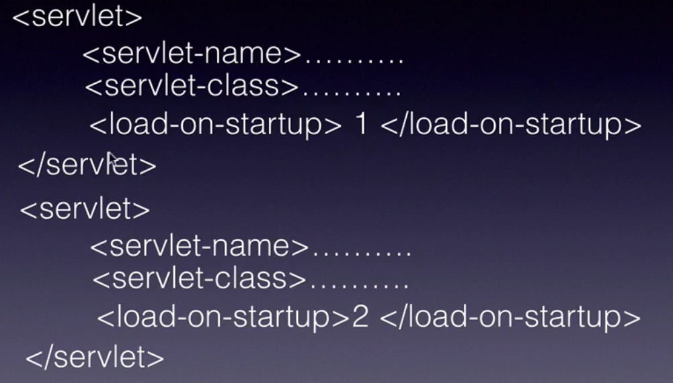

The number indicates the order in which servlets will be pre-initialized. The lower the number, the higher the priority.

Pre-initialization is very useful in cases :

- Web services frameworks like Apache CXF or Jersey
- Spring MVC framework – uses Dispatcher Servlet which is pre-initialized.

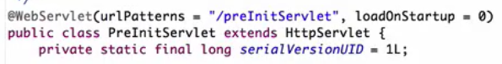

Using annotation to specify loadOnStartup.
ServletListeners :

Enable our application or servlets to react to certain events that happen in the web container. So, web applicaitons can handle those events and take appropriate action if required.

- Request - Request being created/destroyed
- Session - Session being created/destroyed
- Context - Web application being loaded/unloaded
- Async events – like onComplete, onStart, etc

Usecases : to count the number of active users in the session, etc

How it all works ??

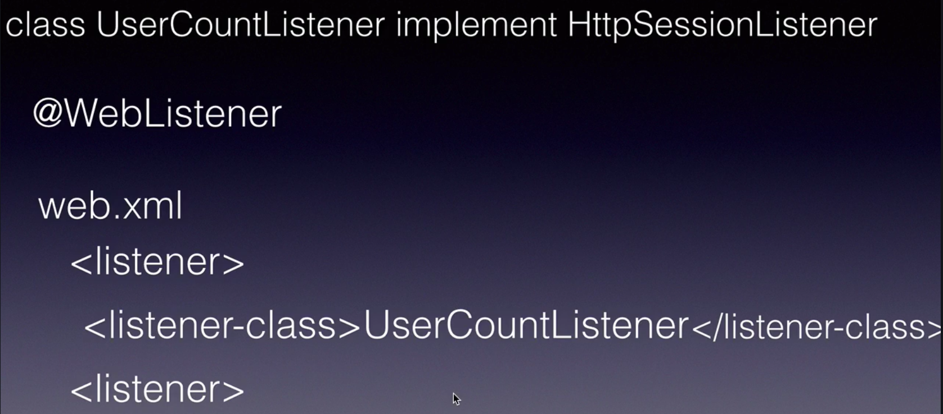

Servlet Filters :

A filter is a Java class that can intercept the request and response cycles of a Servlet.

Any logic that we want to execute before the servlet request is processed by the servlet can be put into the filter. Similary, for the response.

Pre-processing and post-processing logic can be put into filter.

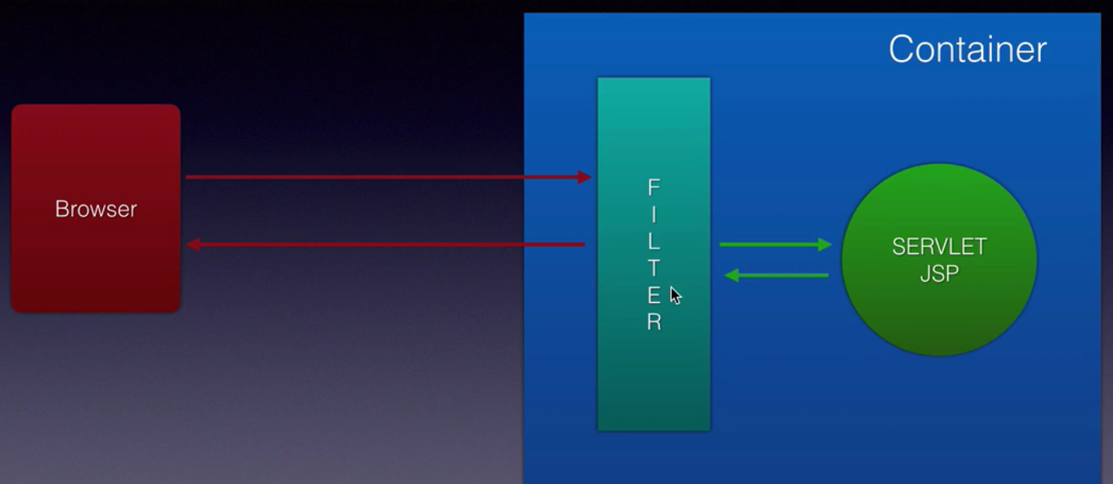

Filter chaining :

Filter chaining is the concept of applying more than one filter to a servlet or a JSP. Example, like one filter doing encryption/decryption stuff and another filter doing zipping/unzipping kind of stuff.

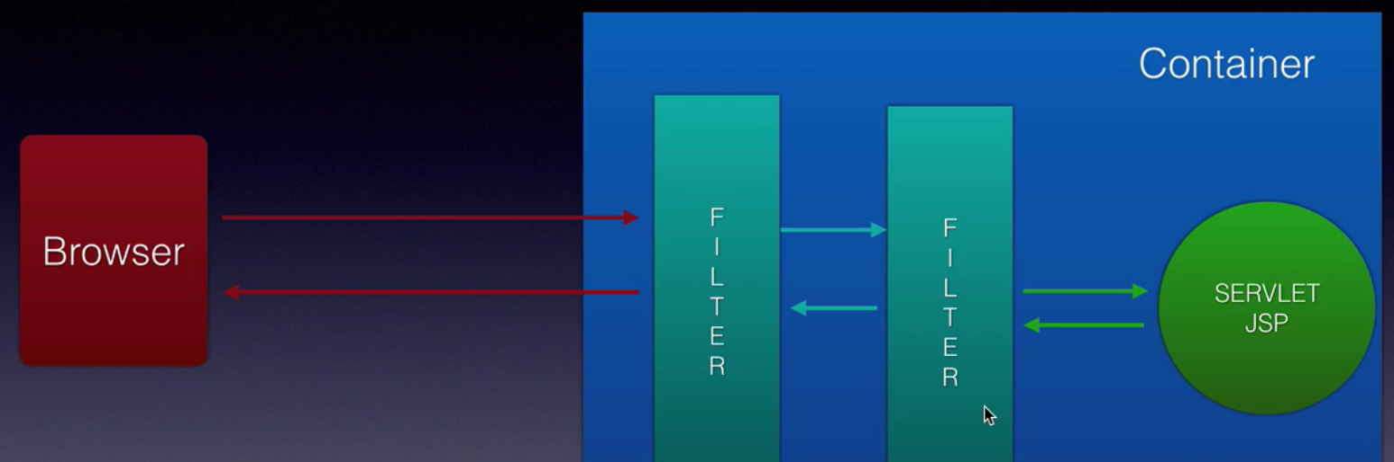

Depends on business requirement, we can have multiple filters handling multiple responsibilities.

A Java class has to implement Filter interface and marked with @Filter annotation.

Filter and its life cycle methods :
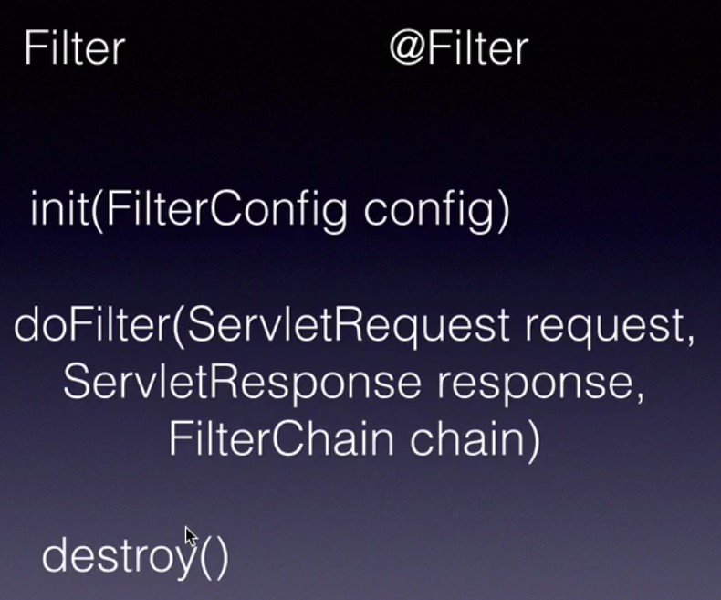

By default, all the filters are pre-initialized. Container initializes them when it comes up.

